**Koneru Lakshmaiah Education Foundation**

**(Deemed to be University)**

**FRESHMAN ENGINEERING DEPARTMENT**

**A Project Based Lab Report**

**On**

**SCHOOL WEBSITE**

**SUBMITTED BY:**

I.D NUMBER NAME

18003060 K.Mohan Sai

180030365 P.Manikantha

**UNDER THE GUIDANCE OF**

**Mrs.Revathi**



**KL UNIVERSITY**

Green fields, Vaddeswaram – 522 502

Guntur Dt., AP, India.

**DEPARTMENT OF BASIC ENGINEERING SCIENCES-II**

****

**CERTIFICATE**

This is to certify that the project based laboratory report entitled **“WEBSITE FOR SCHOOL MANAGEMENT”** submitted by Mr. **K.Mohan Sai ,P. Manikantha** bearing Regd. No.180030360,180030365 To the **Department of Basic Engineering Sciences-II, KL University** in partial fulfillment of the requirements for the completion of a project in “Workshop Practices for Computer Engineers- 18CS1003”course in I B Tech I Semester, is a bonfire record of the work carried out by him/her under my supervision during the academic year 2018 – 2 019.

PROJECT SUPERVISOR HEAD OF THE DEPARTMENT

**Mrs.Revathi**  Dr.S.N.Padhi

**ACKNOWLEDGEMENTS**

It is great pleasure for me to express my gratitude to our honorable President **Sri. KoneruSatyanarayana**, for giving the opportunity and platform with facilities in accomplishing the project based laboratory report.

I express the sincere gratitude to our principal **Prof.Dr. N.Venkataram** for his administration towards our academic growth.

I express sincere gratitude to HOD-BES-II **Dr.S.N.Padhi**for his leadership and constant motivation provided in successful completion of our academic semester. I record it as my privilege to deeply thank for providing us the efficient faculty and facilities to make our ideas into reality.

I express my sincere thanks to our project supervisor for his/her **Mrs.Revathi** novel association of ideas, encouragement, appreciation and intellectual zeal which motivated us to venture this project successfully.

Finally, it is pleased to acknowledge the indebtedness to all those who devoted themselves directly or indirectly to make this project report success.

REGD. NO: NAME:

18003060 K.Mohan Sai

180030365 P.Manikantha

**ABSTRACT**

School Information Management System provides a simple interface for maintenance of school information. It can be used by educational institutes or colleges to maintain the details of their institutes easily. The creation and management of accurate, up-to-date information regarding a schools’ academic career is important. School information system deals with all kind of school details, academic related reports, course details, curriculum, batch details, financial details and other resource related details too. It tracks all the details of a school from the day one to the end of the academic which can be used for all reporting purpose, progress in the course, completed years, coming year curriculum details, exam details, final exam result and all these will be available through a secure, online interface embedded in the school’s website. It will also have faculty details, batch execution details, students’ details in all aspects, the various academic notifications to the staff and students updated by the school administration. It also facilitate us explore all the activities happening in the school, Different reports and Queries can be generated based on vast options related to students, batch, course, faculty, exams, semesters, certification and even for the entire school.

**INDEX**

|  |  |  |
| --- | --- | --- |
| **S.NO** | **TITLE** | **PAGE NO** |
| 1 | Introduction | 6 |
| 2 | Aim of the Project | 7 |
| 3 | Software & Hardware Details | 8 |
| 4 | Module Details | 9 |
|  | 4.1 List of Modules | 9 |
|  | 4.1 Module Description | 10 |
| 5 | Advantages and Disadvantages | 12 |
| 6 | Implementation | 13 |
| 7 | Snapshots | 33 |
| 8 | Conclusion | 39 |

**INTRODUCTION**

 The school’s website must include the following:

* The school’s name
* The school’s postal addres
* The school’s telephone number
* The name of the member of staff who deals with queries from parents and other members of the public
* The content of your school curriculum in each academic year for every subject, including Religious Education even if it is taught as part of another subject or subjects
* The name and contact details of your special educational needs (SEN) co-ordinator (SENCO) unless
* you’re a special school.
* How parents or other members of the public can find out more about the curriculum your school is following
* a list of the courses available to pupils.

**AIM**

To create a website based on School Information Management System by inserting

more than one webpage in Main webpage by using html code. **School Website** is very

important for making a good first impression as it often is the first contact that people have with the school. Therefore, the school website affects the overall image and reputation of your school which can lead to increased admissions. Having a good school website is also very important for delivering a good user experience for its regular users, including teachers, students and parents

**SYSTEM REQUIREMENTS**

* **SOFTWARE REQUIREMENTS:**

The major software requirements of the project are as follows:

Web Browser: Internet Explorer or Google Chrome or Mozilla firefox

Operating system**:**WindowsXp or later.

* **HARDWARE REQUIREMENTS:**

The hardware requirements that map towards the software are as follows:

RAM :8GB

Processor : i7

**Module Details**

**List of Modules**

* Home Page
* Login Page
* Academics
* Campus Life
* Events
* Facilities
* Contact Details

**Module Description**

**Home Page:**

The Home Page consists of brief Introduction of School with some Photos Slide Show. And the Name Of the school and this page connects to the login page of the School. The importance of the Home page is to create the attention of the viewers and the Home Page must be attractive enough to attract parents to join their childerns in the School. [**School website**](http://www.schooljotter.com/) is very important for making a good first impression as it often is the first contact that people have with the school. Therefore, the school website affects the overall image and reputation of your school which can lead to increased admissions. Having a good school website is also very important for delivering a good user experience for its regular users, including teachers, students and parents.

**Login Page:**

The Login Page consists of the details of the Webpage. It consists of:

1.Academics

2.Campus life

3.Facilities

4.Events

5.Contact details

The School Information Management System is important because of:

**Appearance**

The overall look of the website is the first thing that users notice when they visit the website. This includes the layout, colours, images and fonts you use to build the website. Make sure that all these factors are considered when building the website as they contribute towards creating an overall impression of the school.

Make sure you check our info graphic on how to design an awesome school website **[.](http://blog.schooljotter.com/how-to-design-an-awesome-school-website/" \t "_blank" \o "Infographic for school websites)**

**Quality content**

A good school website is expected to include a range of quality content. Remember to add basic information like contact details, welcoming messages, school value and images to the homepage followed by learning resources, curriculum information, news, events calendar and other school information.

**Navigation**

The website design and good content are very important, however, if visitors cannot easily find the information they are looking for, they will become frustrated and it will negatively affect the overall user experience.

This is especially important when talking about parents researching the schools for their children because if they find the website impossible to navigate, they might just leave the website and search for another school.

**The right message**

Make sure your website sends the right message to its visitors and it actually represents the values and promotes the strengths of your school. Your website is very important when it comes to creating the best image of your school.

**Having a school website is very important, but making it a good website is what creates a good image of your school and leads to the positive user experience.**

**ADVANTAGES**

* Many websites display children’s work on the school website, this can improve the self-esteem of the child, resulting to the child working harder.
* Its helps parents/careers/members of the community/students to be involved with the school causing the community to be stronger.
* teachers save time on unnecessary administrative tasks;
* your school can save money on printing, toner, photocopies and sending physical letters to parents;
* finding reports for children becomes easier because you can track things like attendance stats with just a click;
* paying for school meals and trips becomes more convenient for parents.

**DISADVANTAGES**

* Slow Internet connections can cause using school websites to be difficult
* School websites can very complicated to use which is hard for those students and other people who have limited knowledge with   computers.

 Some school websites do not update information regularly which means external users are not aware of new information.

**IMPLEMENTATION**

**Html code**

MAIN PROGRAM:

<!DOCTYPE html>

<html>

<head>

<meta name="viewport" content="width=device-width, initial-scale=1">

<style>

.button {

background-color:purple;

border: none;

color: white;

padding: 15px 32px;

text-align: center;

text-decoration: none;

display: inline-block;

font-size: 16px;

margin: 4px 2px;

cursor: pointer;

}

.container {

position: relative;

text-align: center;

color: white;

}

.centered {

position: absolute;

top: 50%;

left: 50%;

transform: translate(-50%, -50%);

}

.mySlides {display:none;}

</style>

</head>

<body>

<div class="container" style="max-width:1000px">

<img class="mySlides" src="s1.jpg" style="width:200%">

<img class="mySlides" src="s6.jpg" style="width:200%">

<img class="mySlides" src="s4.jpg" style="width:200%">

<img class="mySlides" src="s2.jpg" style="width:200%">

<div class="centered"><h1><font size="13">AKSHAYA SCHOOL OF LEARNING.......</font></h1><form action="login.html">

<input type="submit" class="button" value="CLICK HERE"><br>to view full page

</form></div>

</div>

<script>

var myIndex = 0;

carousel();

function carousel() {

var i;

var x = document.getElementsByClassName("mySlides");

for (i = 0; i < x.length; i++) {

x[i].style.display = "none";

}

myIndex++;

if (myIndex > x.length) {myIndex = 1}

x[myIndex-1].style.display = "block";

setTimeout(carousel, 2000); // Change image every 2 seconds

}

</script>

</body>

</html>

**Sub Program 1 for Login webpage:**

<!DOCTYPE html>

<html>

<head>

<meta name="viewport" content="width=device-width, initial-scale=1">

<style>

.button {

background-color: #4CAF50;

border: none;

color: white;

padding: 15px 32px;

text-align: center;

text-decoration: none;

display: inline-block;

font-size: 16px;

margin: 4px 2px;

cursor: pointer;

}

.centered {

position: absolute;

top: 50%;

left: 50%;

transform: translate(-50%, -50%);

}

</style>

</head>

<body>

<div class="container">

<img src="l1.jpg" alt="Snow" style="width:300%;">

<div class="centered"><form action="aca.html"><br><br><br><br>

<input type="submit" class="button" value=" ACADEMICS">

</form><br><form action="fac.html">

<input type="submit" class="button" value=" FACILITIES">

</form><br><form action="events.html">

<input type="submit" class="button" value=" EVENTS ">

</form><br><form action="campuslife.html">

<input type="submit" class="button" value="CAMPUS LIFE">

</form><br><form action="contact.html">

<input type="submit" class="button" value="CONTACT US">

</form></div></div>

</div>

</body>

</html>

**Sub Program 2 for Academics webpage:**

<!DOCTYPE html>

<html>

<head>

<meta name="viewport" content="width=device-width, initial-scale=1">

<style>

.button {

background-color:purple;

border: none;

color: white;

padding: 15px 32px;

text-align: center;

text-decoration: none;

display: inline-block;

font-size: 16px;

margin: 4px 2px;

cursor: pointer;

}

.button1 {

background-color: #4CAF50;

border: none;

color: white;

padding: 10px 5px;

text-align: center;

text-decoration: none;

display: inline-block;

font-size: 10px;

margin: 4px 2px;

cursor: pointer;

}

.container {

position: relative;

text-align: center;

color: white;

}

.centered {

position: absolute;

top: 50%;

left: 50%;

transform: translate(-50%, -50%);

}

.mySlides {display:none;}

</style>

</head>

<body>

<div class="container" style="max-width:1000px">

<img class="mySlides" src="a1.jpg" style="width:150%">

<img class="mySlides" src="a2.jpg" style="width:150%">

<img class="mySlides" src="a3.jpg" style="width:150%">

<form action="login.html">

<input type="submit" class="button1" value="back">

</form>

<div class="centered"><h1><font size="9">"To impart quality higher education and to undertake research and extension with emphasis on

application and innovation that cater to the emerging societal needs through all-round

development of students of all sections enabling them to be globally competitive and socially

responsible citizens with intrinsic values"</font><br></div>

</div>

<script>

var myIndex = 0;

carousel();

function carousel() {

var i;

var x = document.getElementsByClassName("mySlides");

for (i = 0; i < x.length; i++) {

x[i].style.display = "none";

}

myIndex++;

if (myIndex > x.length) {myIndex = 1}

x[myIndex-1].style.display = "block";

setTimeout(carousel, 2000); // Change image every 2 seconds

}

</script>

</body>

</html>

**Sub Program 3 for Campus Life webpage:**

<!DOCTYPE html>

<html>

<head>

<meta name="viewport" content="width=device-width, initial-scale=1">

<style>

.button {

background-color:purple;

border: none;

color: white;

padding: 15px 32px;

text-align: center;

text-decoration: none;

display: inline-block;

font-size: 16px;

margin: 4px 2px;

cursor: pointer;

}

.button1 {

background-color: #4CAF50;

border: none;

color: white;

padding: 10px 5px;

text-align: center;

text-decoration: none;

display: inline-block;

font-size: 10px;

margin: 4px 2px;

cursor: pointer;

}

.container {

position: relative;

text-align: center;

color: white;

}

.centered {

position: absolute;

top: 50%;

left: 50%;

transform: translate(-50%, -50%);

}

.mySlides {display:none;}

</style>

</head>

<body>

<div class="container" style="max-width:1000px">

<img class="mySlides" src="c2.jpg" style="width:150%">

<img class="mySlides" src="c4.jpg" style="width:150%">

<img class="mySlides" src="c1.jpg" style="width:150%">

<img class="mySlides" src="c5.jpg" style="width:150%">

<form action="login.html">

<input type="submit" class="button1" value="back">

</form>

<div class="centered"><h1><font size="9">"STUDENTS ENJOY LEARNING IN SCHOOL.THEY FEEL THE JOY OF LEARNING"</font><br></div>

</div>

<script>

var myIndex = 0;

carousel();

function carousel() {

var i;

var x = document.getElementsByClassName("mySlides");

for (i = 0; i < x.length; i++) {

x[i].style.display = "none";

}

myIndex++;

if (myIndex > x.length) {myIndex = 1}

x[myIndex-1].style.display = "block";

setTimeout(carousel, 2000); // Change image every 2 seconds

}

</script>

</body>

</html>

**Sub Program 4 for Event webpage:**

<!DOCTYPE html>

<html>

<head>

<meta name="viewport" content="width=device-width, initial-scale=1">

<style>

.button {

background-color:purple;

border: none;

color: white;

padding: 15px 32px;

text-align: center;

text-decoration: none;

display: inline-block;

font-size: 16px;

margin: 4px 2px;

cursor: pointer;

}

.button1 {

background-color: #4CAF50;

border: none;

color: white;

padding: 10px 5px;

text-align: center;

text-decoration: none;

display: inline-block;

font-size: 10px;

margin: 4px 2px;

cursor: pointer;

}

.container {

position: relative;

text-align: center;

color: white;

}

.centered {

position: absolute;

top: 50%;

left: 50%;

transform: translate(-50%, -50%);

}

.mySlides {display:none;}

</style>

</head>

<body>

<div class="container" style="max-width:1000px">

<img class="mySlides" src="e7.jpg" style="width:150%">

<img class="mySlides" src="e8.jpg" style="width:150%">

<img class="mySlides" src="e11.jpg" style="width:150%">

<form action="login.html">

<input type="submit" class="button1" value="back">

</form>

<div class="centered"><h1><font size="9">"In an exhibition, students get a chance to apply or do the practical aspect of the things that they have learned from the Science exhibitionclassroom. These are real opportunities for the kids to easily implement the things that they have learn from schools."</font><br></div>

</div>

<script>

var myIndex = 0;

carousel();

function carousel() {

var i;

var x = document.getElementsByClassName("mySlides");

for (i = 0; i < x.length; i++) {

x[i].style.display = "none";

}

myIndex++;

if (myIndex > x.length) {myIndex = 1}

x[myIndex-1].style.display = "block";

setTimeout(carousel, 2000); // Change image every 2 seconds

}

</script>

</body>

</html>

**Sub Program 5 for Facilities webpage:**

<!DOCTYPE html>

<html>

<head>

<meta name="viewport" content="width=device-width, initial-scale=1">

<style>

.button {

background-color:purple;

border: none;

color: white;

padding: 15px 32px;

text-align: center;

text-decoration: none;

display: inline-block;

font-size: 16px;

margin: 4px 2px;

cursor: pointer;

}

.container {

position: relative;

text-align: center;

color: white;

}

.button1 {

background-color: #4CAF50;

border: none;

color: white;

padding: 10px 5px;

text-align: center;

text-decoration: none;

display: inline-block;

font-size: 10px;

margin: 4px 2px;

cursor: pointer;

}

.centered {

position: absolute;

top: 50%;

left: 50%;

transform: translate(-50%, -50%);

}

.mySlides {display:none;}

</style>

</head>

<body>

<div class="container" style="max-width:1000px">

<img class="mySlides" src="f1.jpg" style="width:200%">

<img class="mySlides" src="f2.jpg" style="width:200%">

<img class="mySlides" src="f3.jpg" style="width:200%">

<form action="login.html">

<input type="submit" class="button1" value="back">

</form>

<div class="centered"><h1><font size="9"><br>"Good schools combine classroom teaching with laboratory experiments to ensure that their students grasp each and every concept thoroughly. It is also believed that laboratory teaching and experiments that are being conducted here help encourage deep understanding in children."</font><br></div>

</div>

<script>

var myIndex = 0;

carousel();

function carousel() {

var i;

var x = document.getElementsByClassName("mySlides");

for (i = 0; i < x.length; i++) {

x[i].style.display = "none";

}

myIndex++;

if (myIndex > x.length) {myIndex = 1}

x[myIndex-1].style.display = "block";

setTimeout(carousel, 2000); // Change image every 2 seconds

}

</script>

</body>

</html>

**Sub Program 6 for Contact webpage:**

<!DOCTYPE html>

<html>

<head>

<meta name="viewport" content="width=device-width, initial-scale=1">

<style>

.centered {

position: absolute;

top: 50%;

left: 50%;

transform: translate(-50%, -50%);

}

.button1 {

background-color: #4CAF50;

border: none;

color: white;

padding: 10px 5px;

text-align: center;

text-decoration: none;

display: inline-block;

font-size: 10px;

margin: 4px 2px;

cursor: pointer;

}

</style>

</head>

<body>

<div class="container">

<img src="b4.jpg" alt="Snow" style="width:150%;">

<div class="centered"><h1><font size="9"><br>contact us:<br>akshay@aks.in<br><br>ping us:<br>akshay.fb.in<br><br>call us at:<br>988748374873<br><br></font><br></div></div></div>

<form action="login.html">

<input type="submit" class="button1" value="back">

</form>

</div>

</body>

</html>

**SCREEN SHOTS**

**1.Home Page**

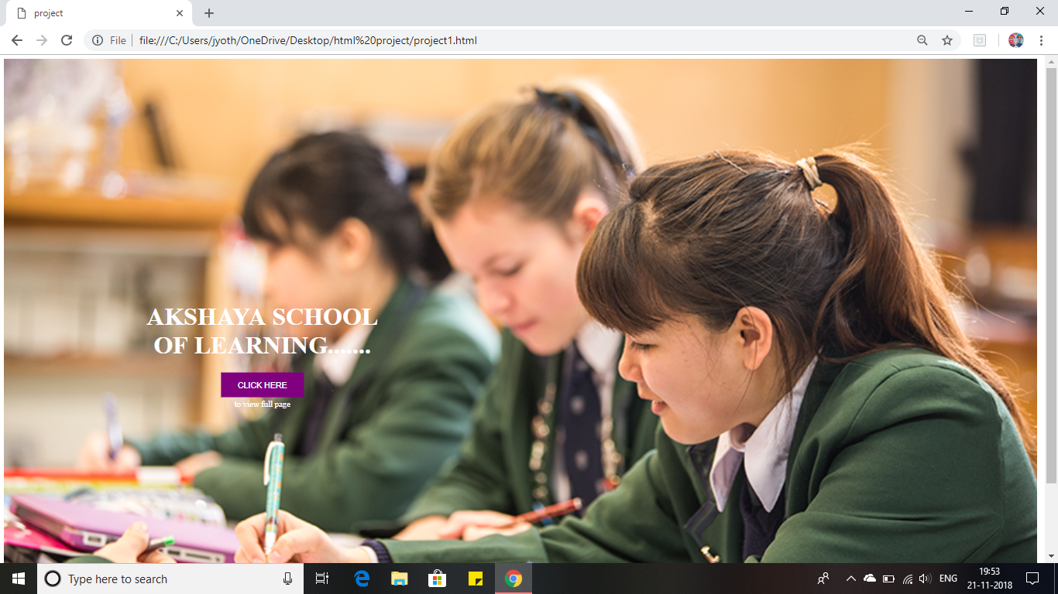

**2.Login Page**

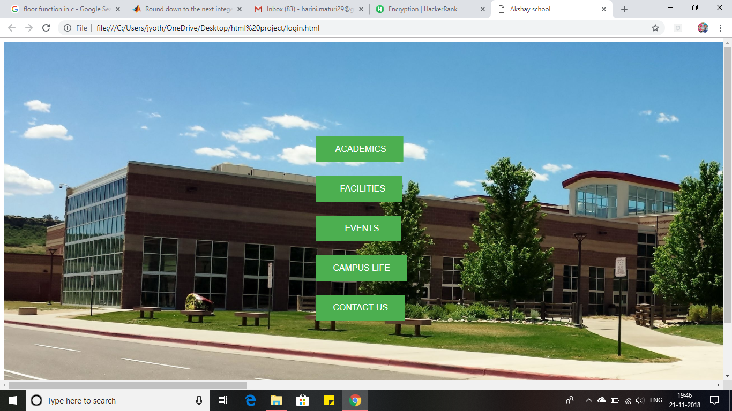

**3.Academics**



**4.Facilities**

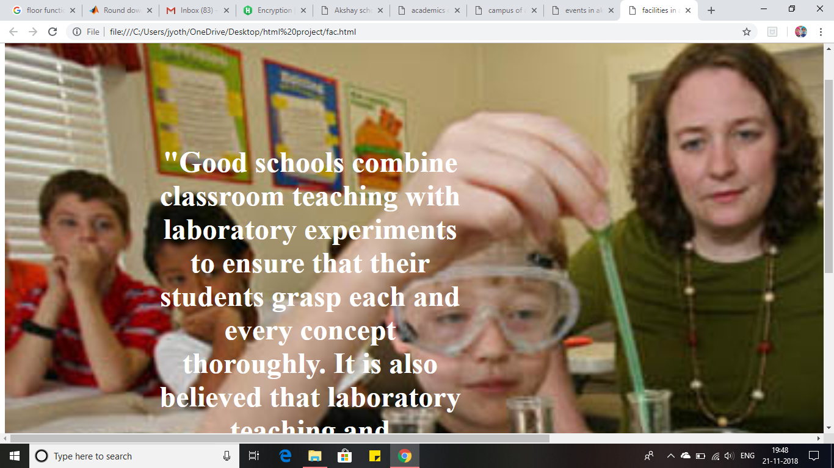

**5.Events:**

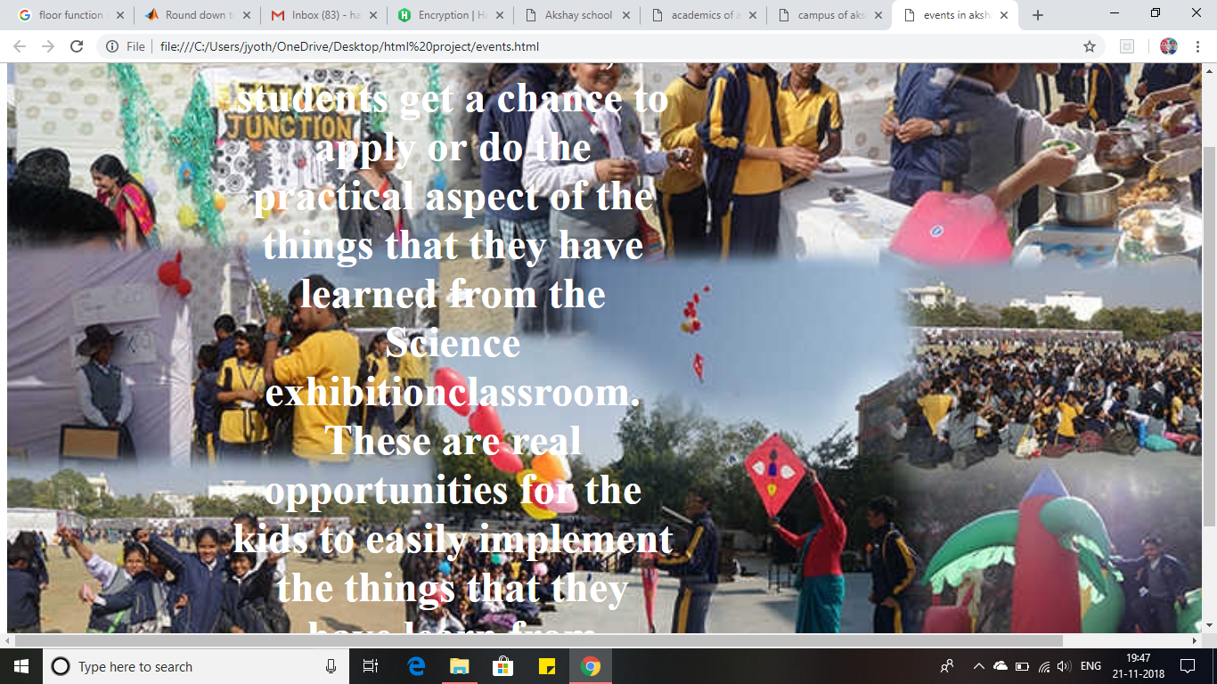

**6.Campus Life:**



**7.Contact:**

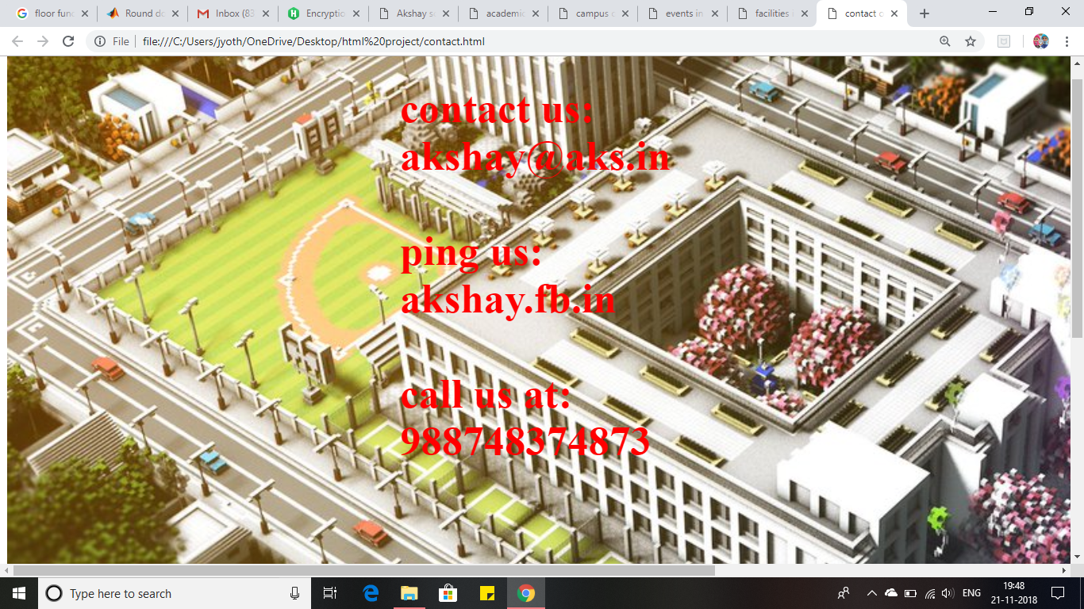

**CONCLUSION**

Here in this project we have created an group of web pages to form a website on **School Information Management System** and came to know how to create a html code for any webpages